Logical Address 🡪 IP Address  
Physical Address 🡪 MAC Address

# ARP (Address Resolution Protocol)

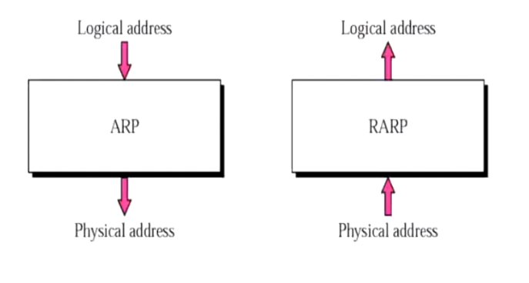

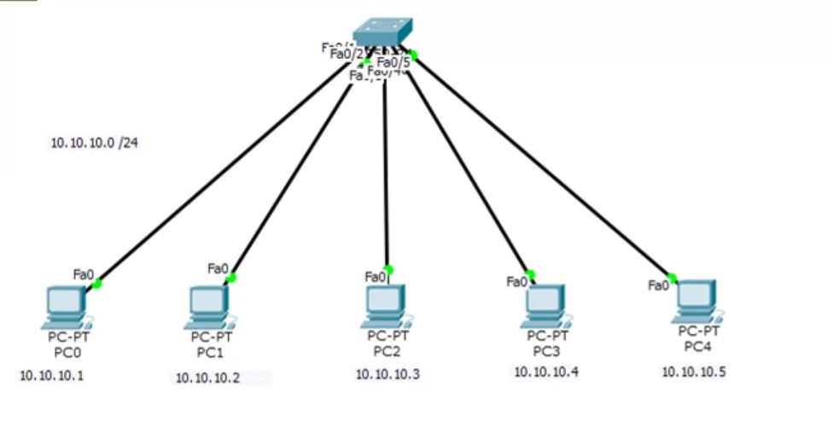

10.10.10.0/24 🡪 IP address of the entire network  
10.10.10.1 🡪 IP address of PC-0  
10.10.10.2 🡪 IP address of PC-1  
10.10.10.3 🡪 IP address of PC-2  
10.10.10.4 🡪 IP address of PC-3  
10.10.10.5 🡪 IP address of PC-4

For a PC to communicate to another PC within a local network, only IP address of that particular PC is not sufficient. Particular PC’s MAC address is also required.

Eg: PC1 wants to communicate with PC3.

## **Checking Local Cache table**

We will check in the cache table of PC1 whether PC3’s MAC address is already available/not.

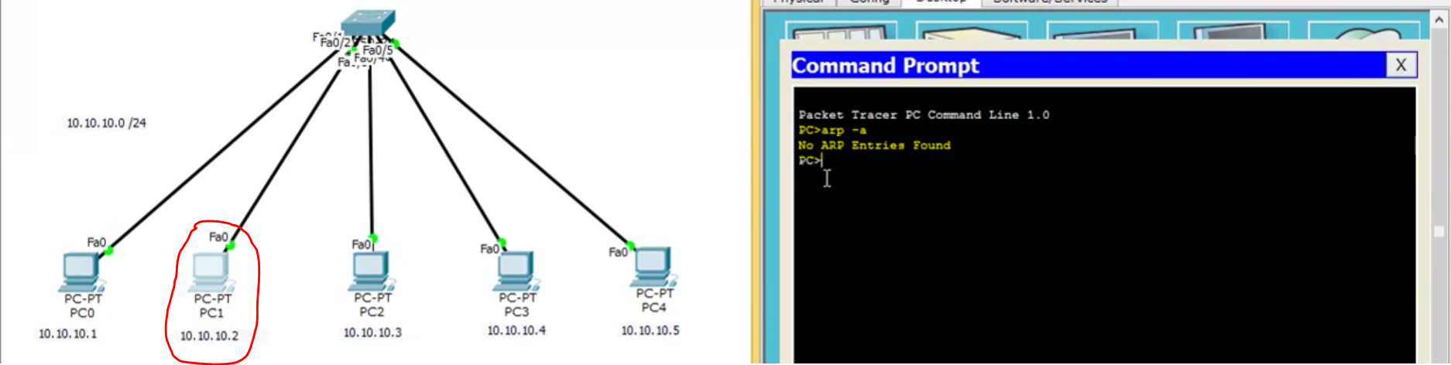  
Cache table 🡪 PC 3’s MAC address is available. Without generating any ARP request ,PC1 can send the ICP packets directly with PC3.

## **MAC Address not available**

Cache table 🡪 PC 3’s MAC address is not available. So PC1 will send the ARP request to the PC whose IP is 10.10.10.4 to the switch.   
**ARP packet 🡪 green envelope**  
**ICMP packet 🡪 red envelope**

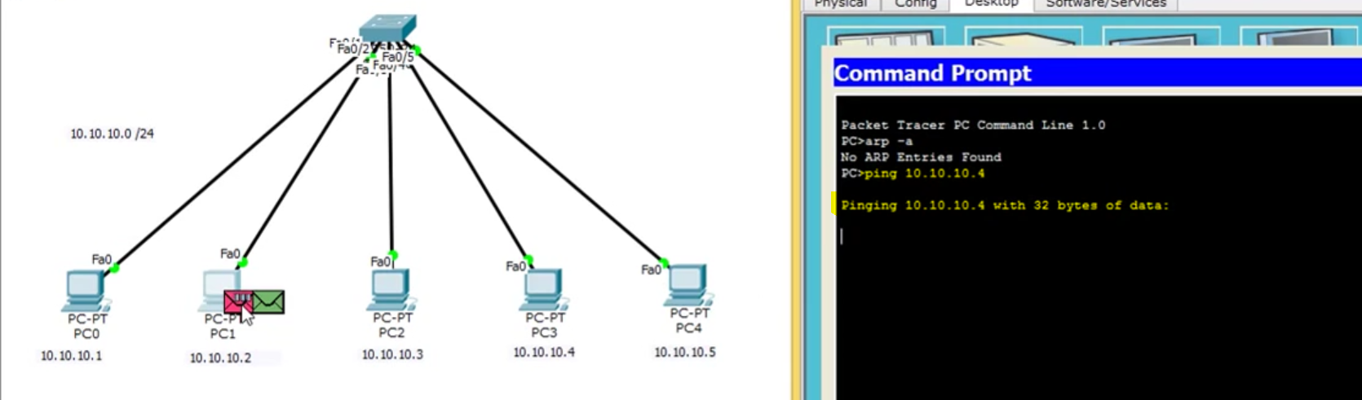   
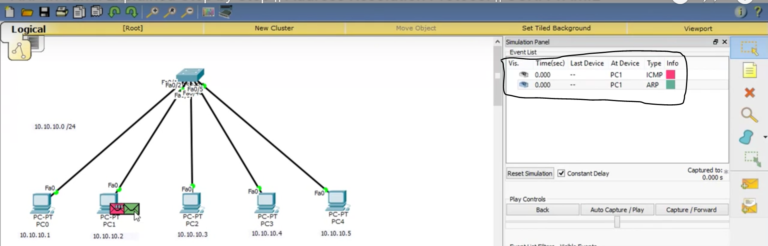

## **Inside ARP packet**

What is inside ARP packet ??

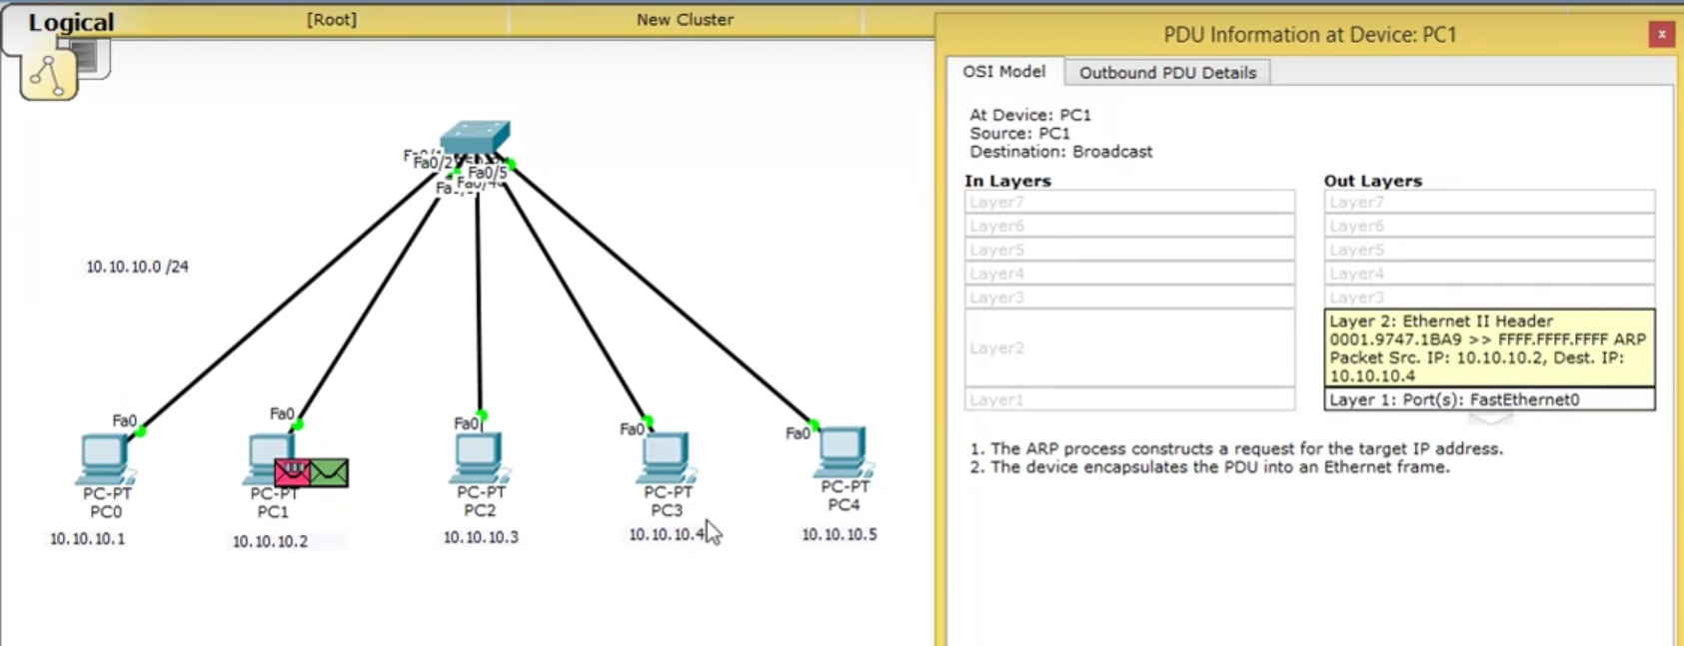

Source MAC Address (PC-1) 🡪 0001.9747.1BA9   
Source IP Address (PC-1) 🡪 10.10.10.2

Destination MAC Address (PC-3) 🡪 FFFF.FFFF.FFFF   
[ Initially PC-3’s MAC address is not known ]  
Source IP Address (PC-3) 🡪 10.10.10.4

## **ARP packet to switch**

Then that **ARP packet 🡪 green envelope** is sent to the switch

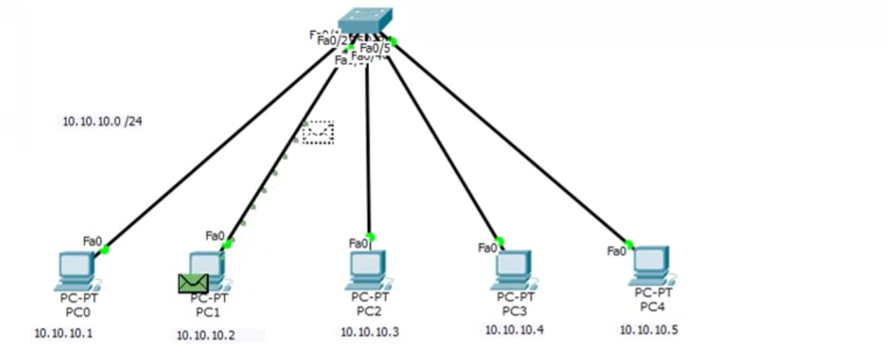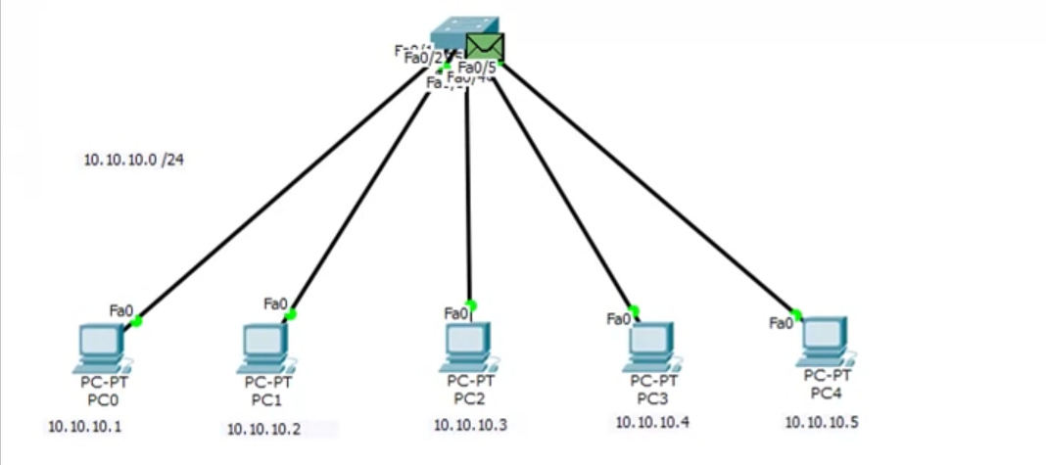

**ARP packet 🡪 green envelope** reached the switch.

## **(Request) Broadcasting the ARP packets to the entire network**

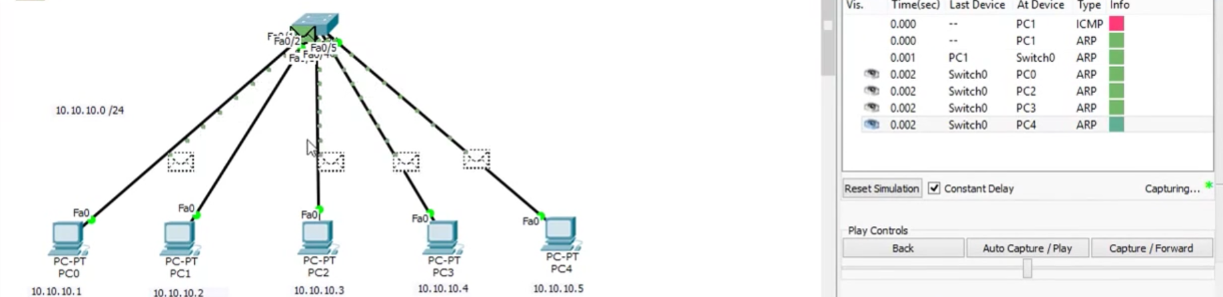

Then that switch will broadcast the **ARP packet 🡪 green envelope** to the entire PC’s in the network except PC-3 (since ARP packet was sent from PC-3)

## **Response From the entire network**

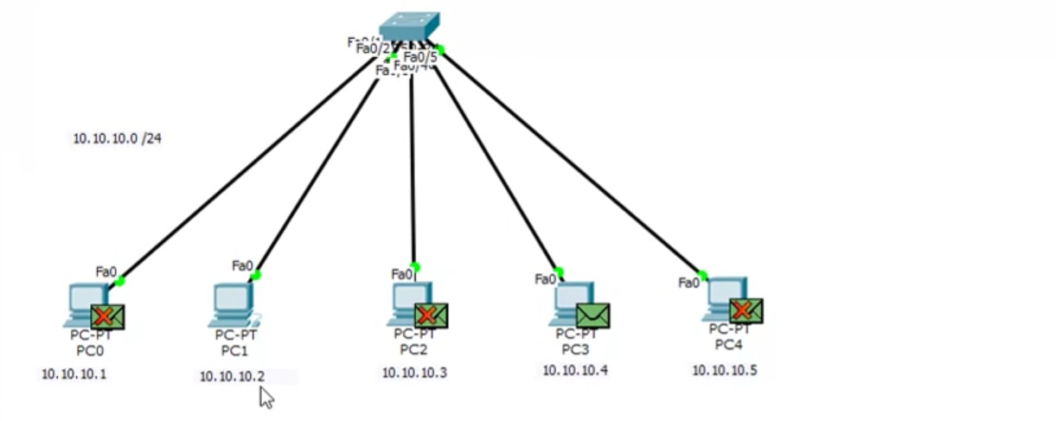

X marks indicates that 10.10.10.4 does not belong to PC-0, PC-2 and PC-4.  
10.10.10.4 belongs to PC-3. So there is no X mark.

## **Opening the message in PC-3**

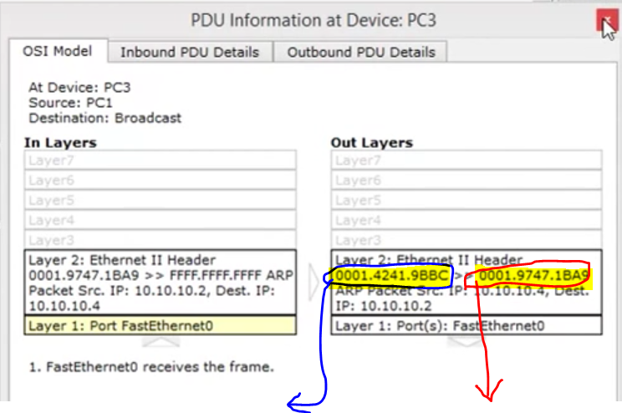

PC-3’s MAC address PC-1’s MAC address

Source IP (PC-3) 🡪 10.10.10.4  
Destination IP (PC-1) 🡪 10.10.10.2

## **Sending the reply message from PC-3 to PC-1**

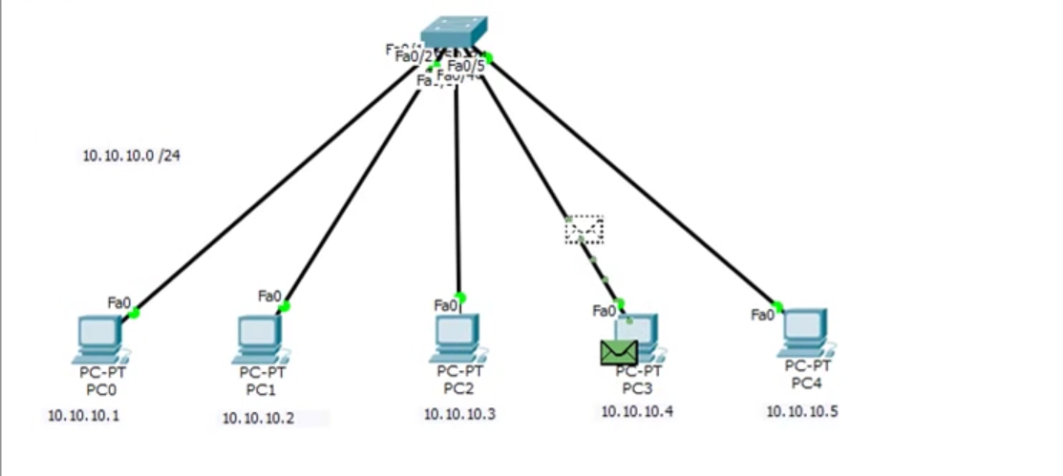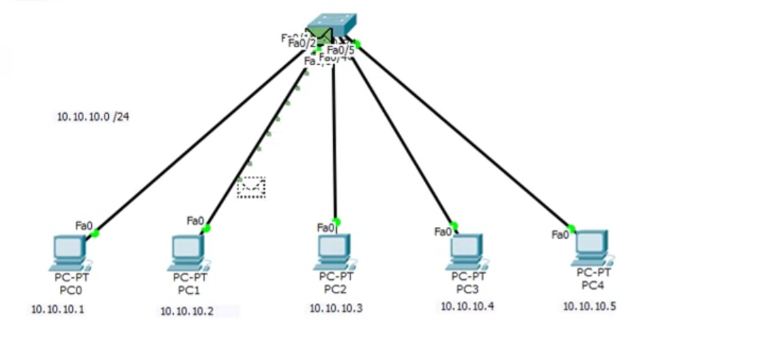

## **PC-1 knows the MAC address of PC-3**

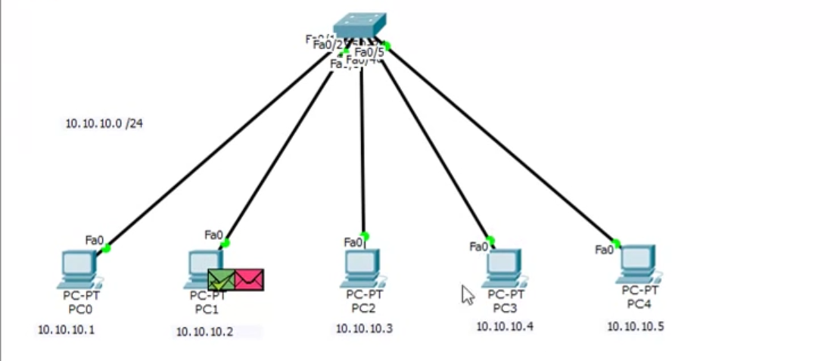

* Indicates that PC-1 got the MAC address of PC-3 and PC-1 is ready to send the ICMP packets.

## **PC-1 to PC-3**

PC-1 sends the **ICMP packet 🡪 red envelope** directly to PC-3.